SQL

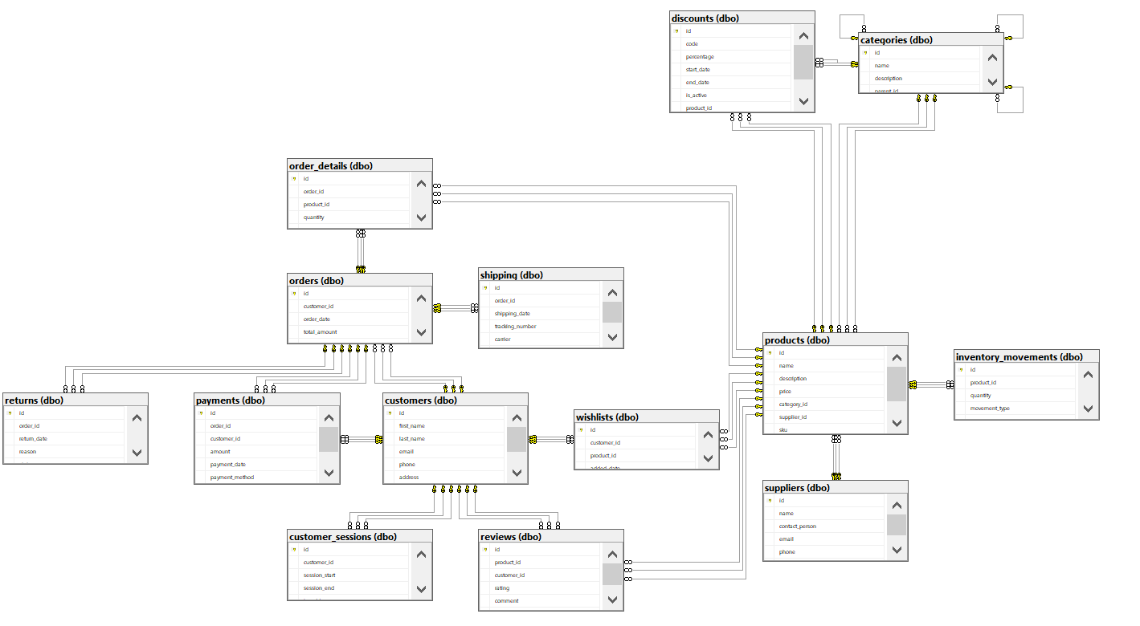

1. Cleaning the data

* Checking for duplicates
* 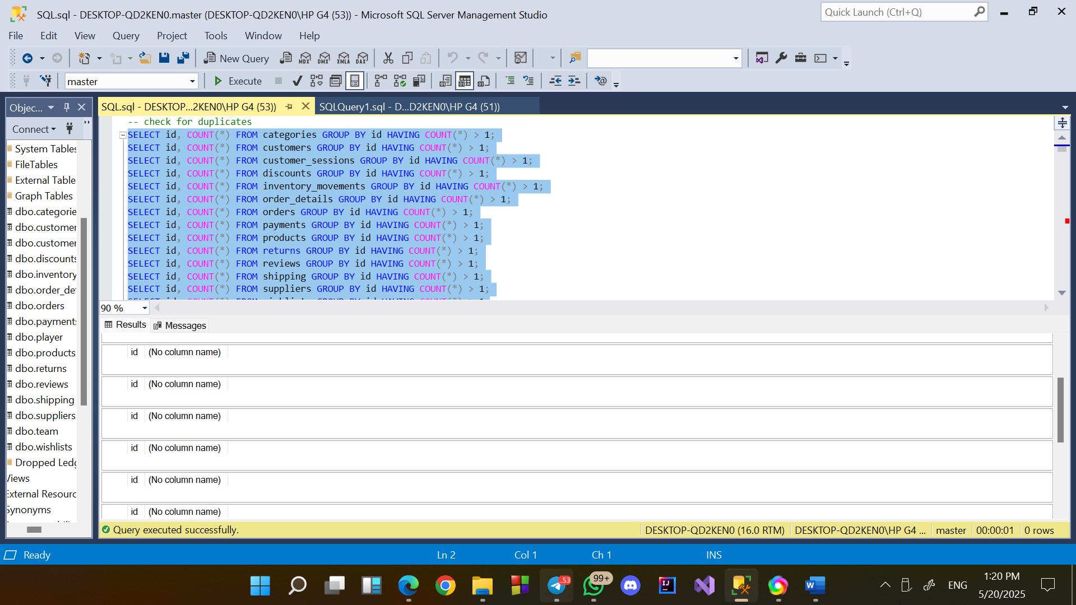

Checking for nulls

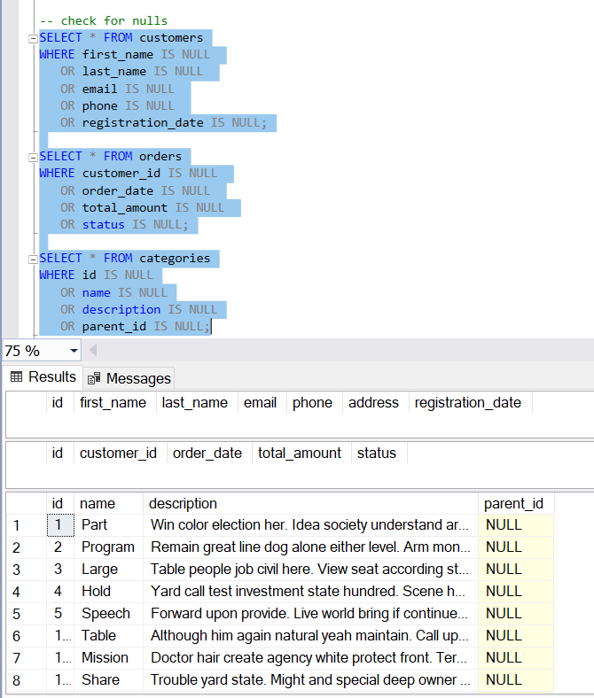

* Dynamic SQL to check all tables in a database

Instead of repeating the same query for each table, we used a dynamic SQL query that scans all tables in the database and reports the number of NULLs per column.

The script uses the INFORMATION_SCHEMA.COLUMNS view to automatically build and run the NULL-check query.

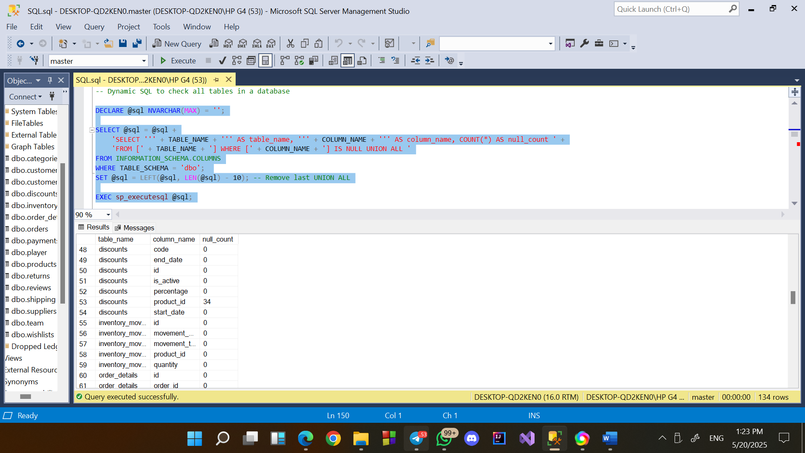

* Checking for outliers

Products table

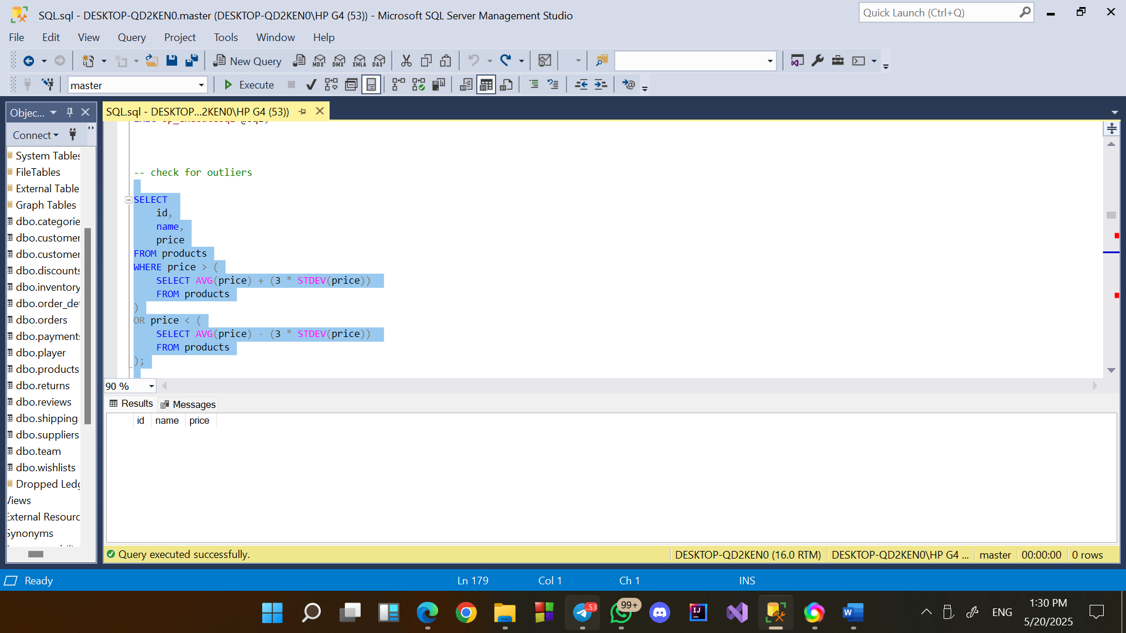

Orders table

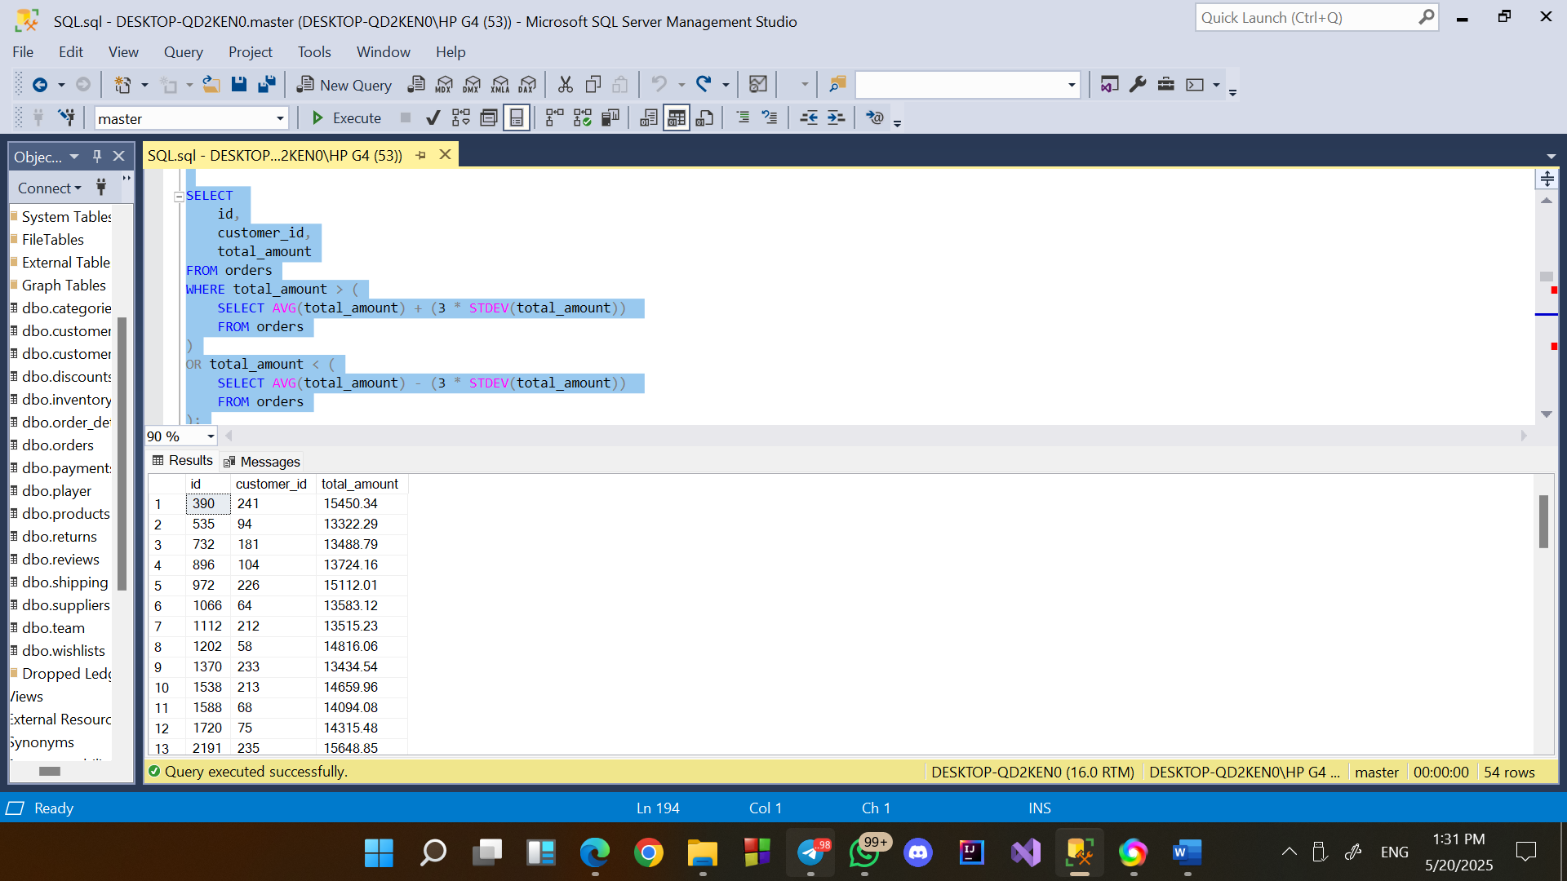

* Check for Impossible or Suspicious Values
* Negative or zero prices

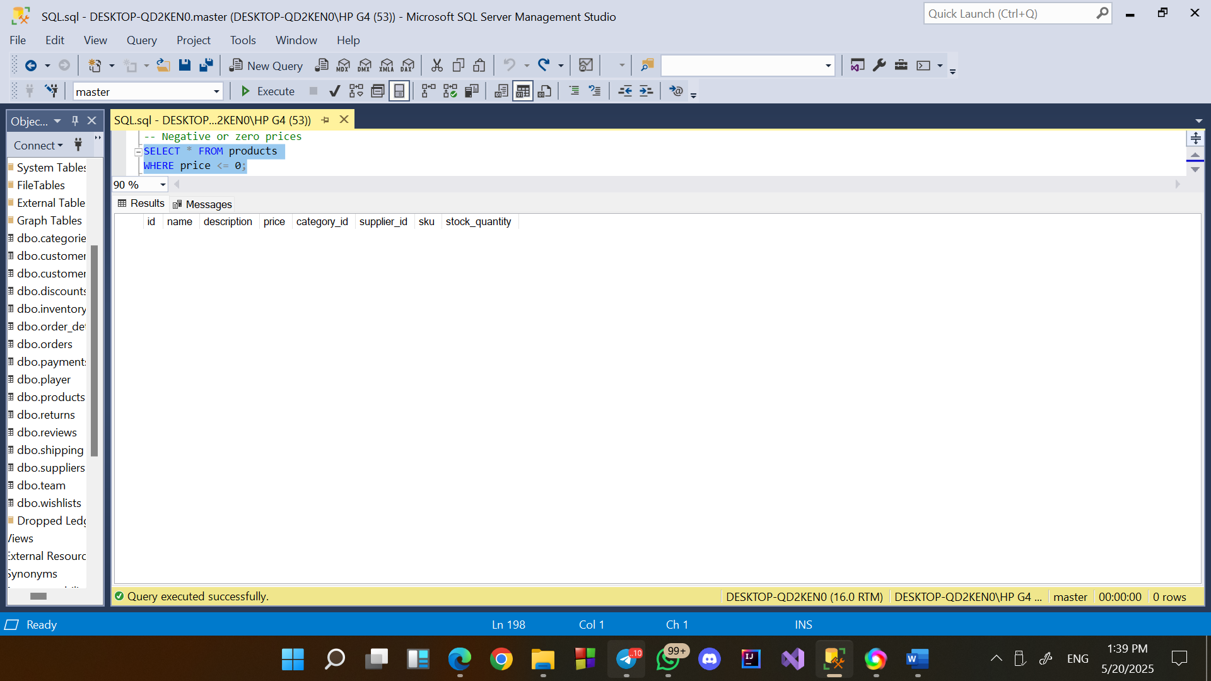

* Orders with zero or negative total

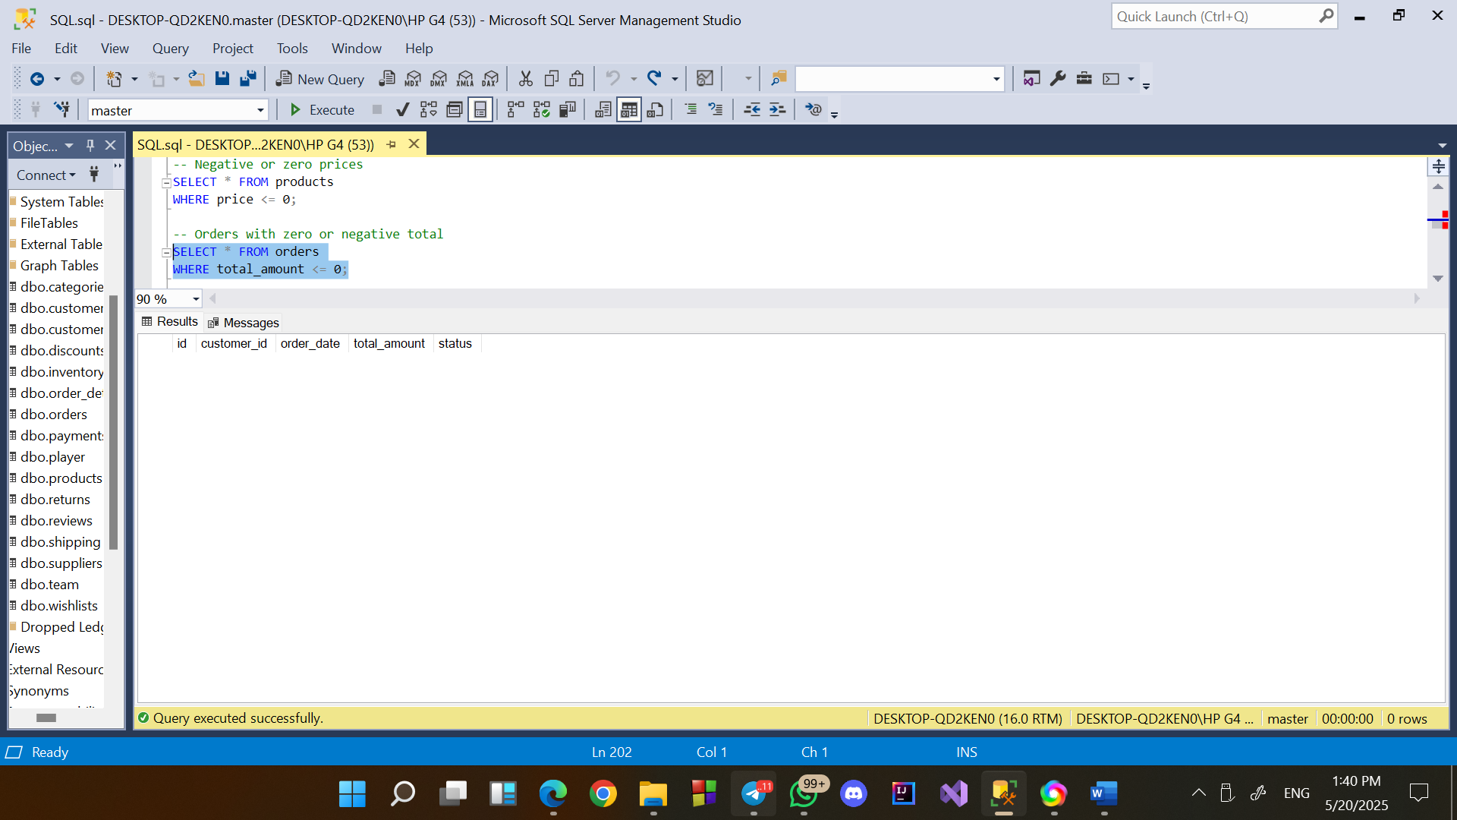

* Inventory movements with zero quantity

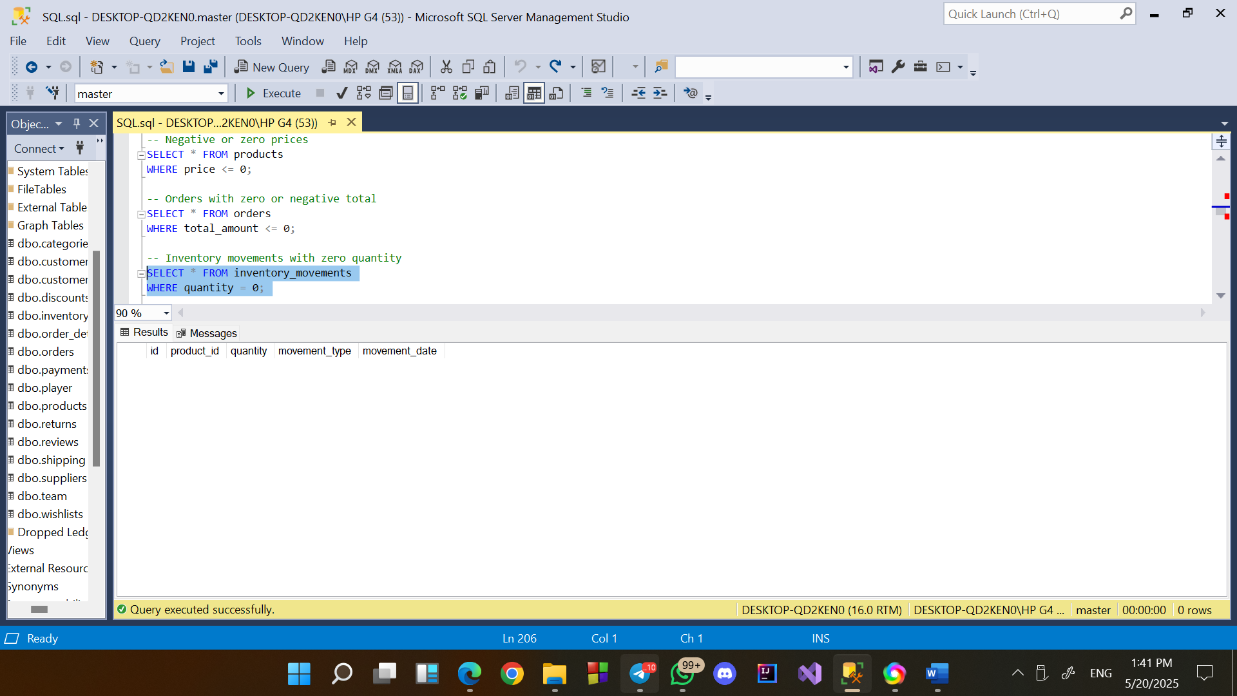

* customers with no orders

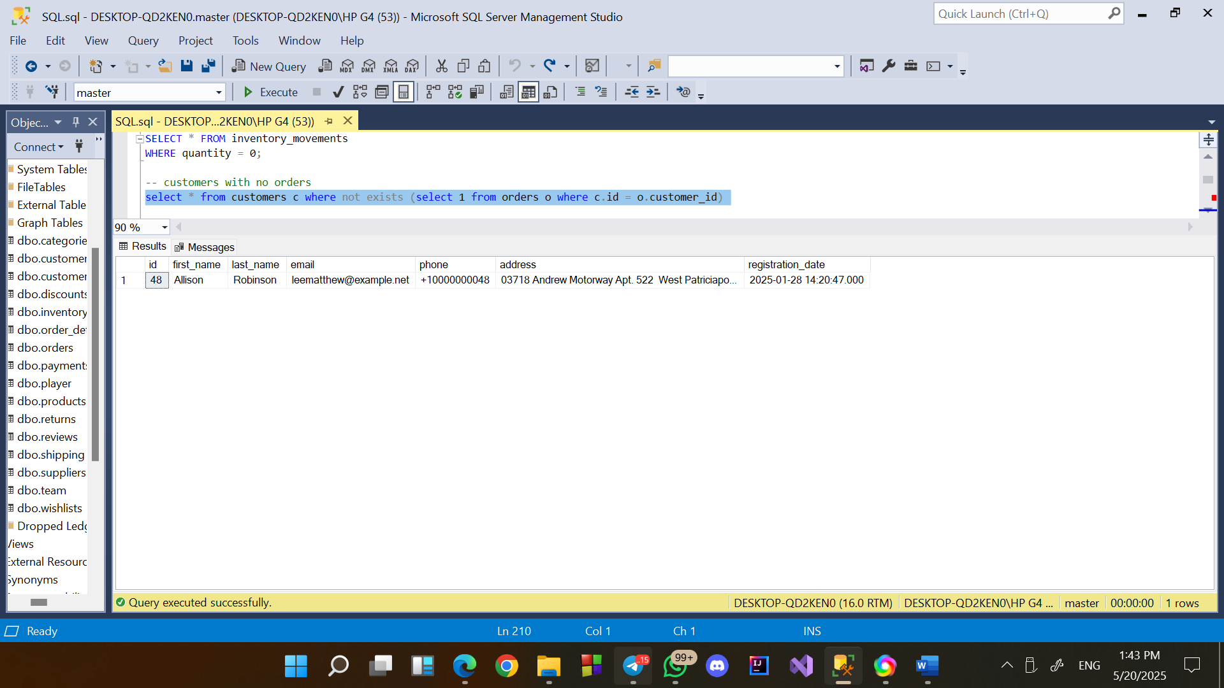

* Check Foreign Key Violations
* Orders without valid customers

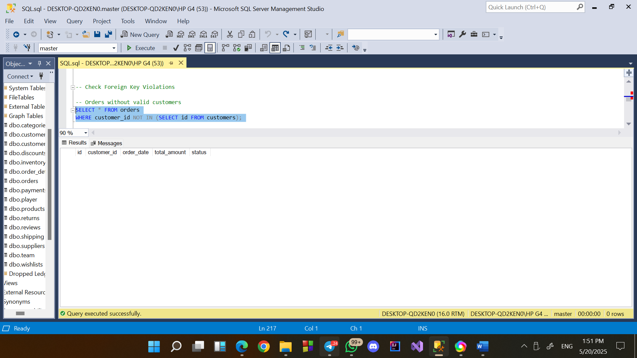

* Order details with invalid products

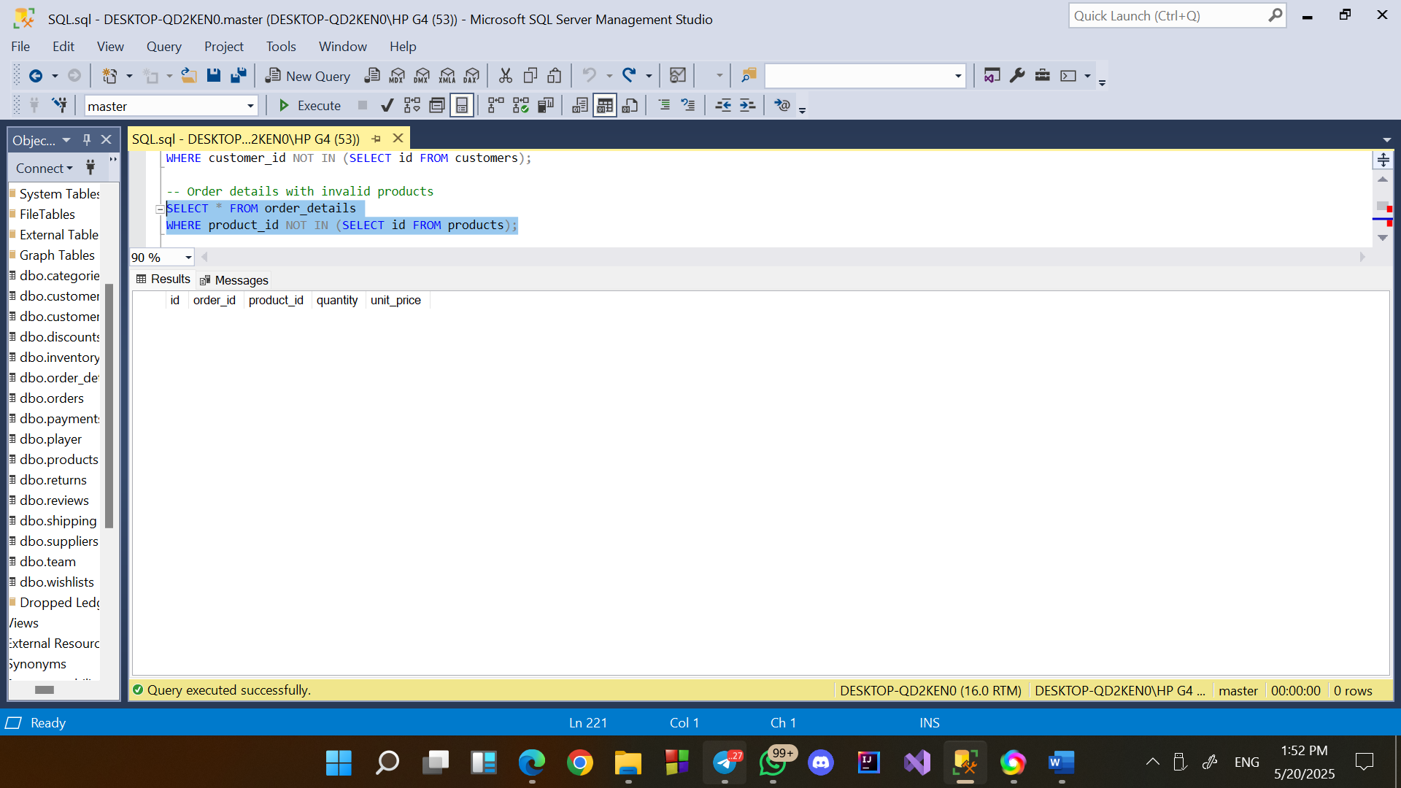

* Check for Unused Products

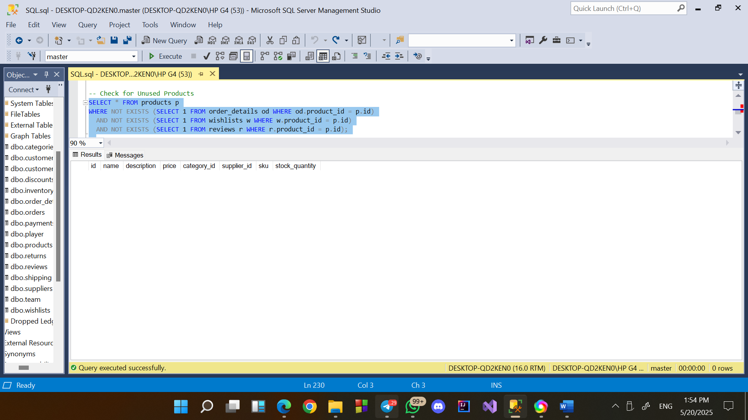

2. Project requirements

* Identify customers with the highest number of orders.

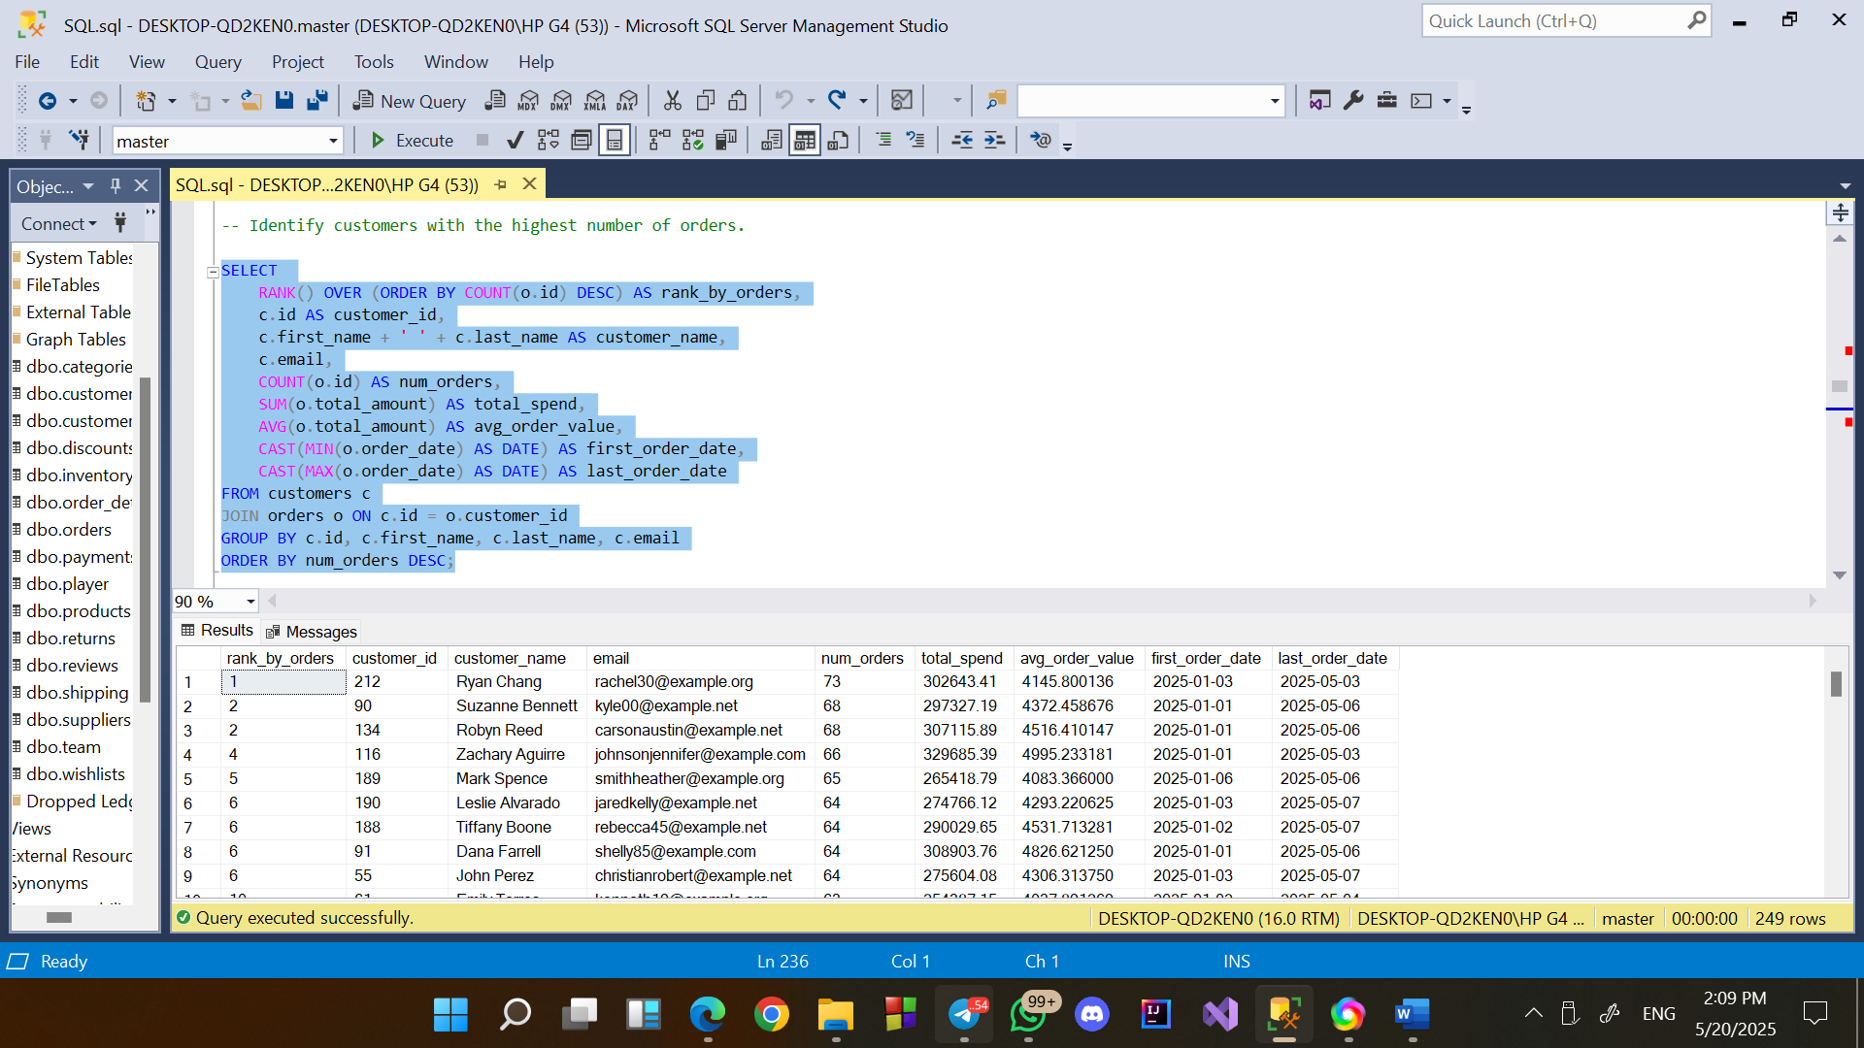

**1. Launch a Loyalty Program**

* Reward top customers with points, discounts, or exclusive benefits.
* Encourage repeat purchases and increase customer retention.

**2. Create VIP Customer Tiers**

* Introduce “Gold” or “Platinum” levels for frequent buyers.
* Offer perks like early access, premium support, or free shipping.

**3. Collect Direct Feedback**

* Engage top customers through surveys or feedback forms.
* Use insights to enhance user experience and service quality.
* Recommend products frequently bought together with items in customer wishlists

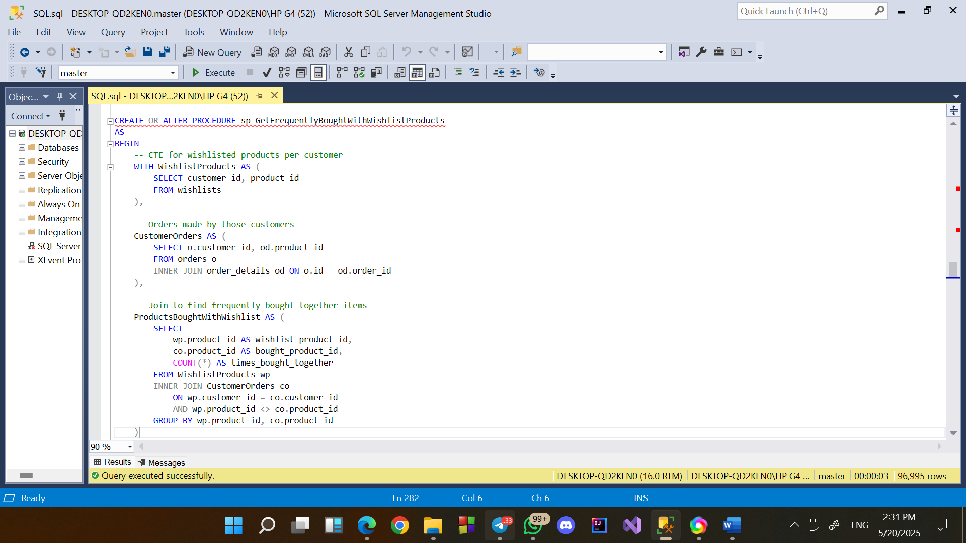

**1. Implement Smart Product Bundles**

* Create dynamic bundles featuring wishlist items and their frequently bought companions.
* Offer bundle discounts to encourage larger cart sizes.

**2. Cart Suggestions Based on Wishlist**

* At checkout, recommend products commonly bought with items from the customer’s wishlist.
* Increase average order value with timely, relevant prompts.

**3. Targeted Ads Based on Wishlist Associations**

* Retarget users with ads showing complementary products.
* Use high-conversion bundles in social and display ads.
* Calculate the time taken to deliver orders in days.

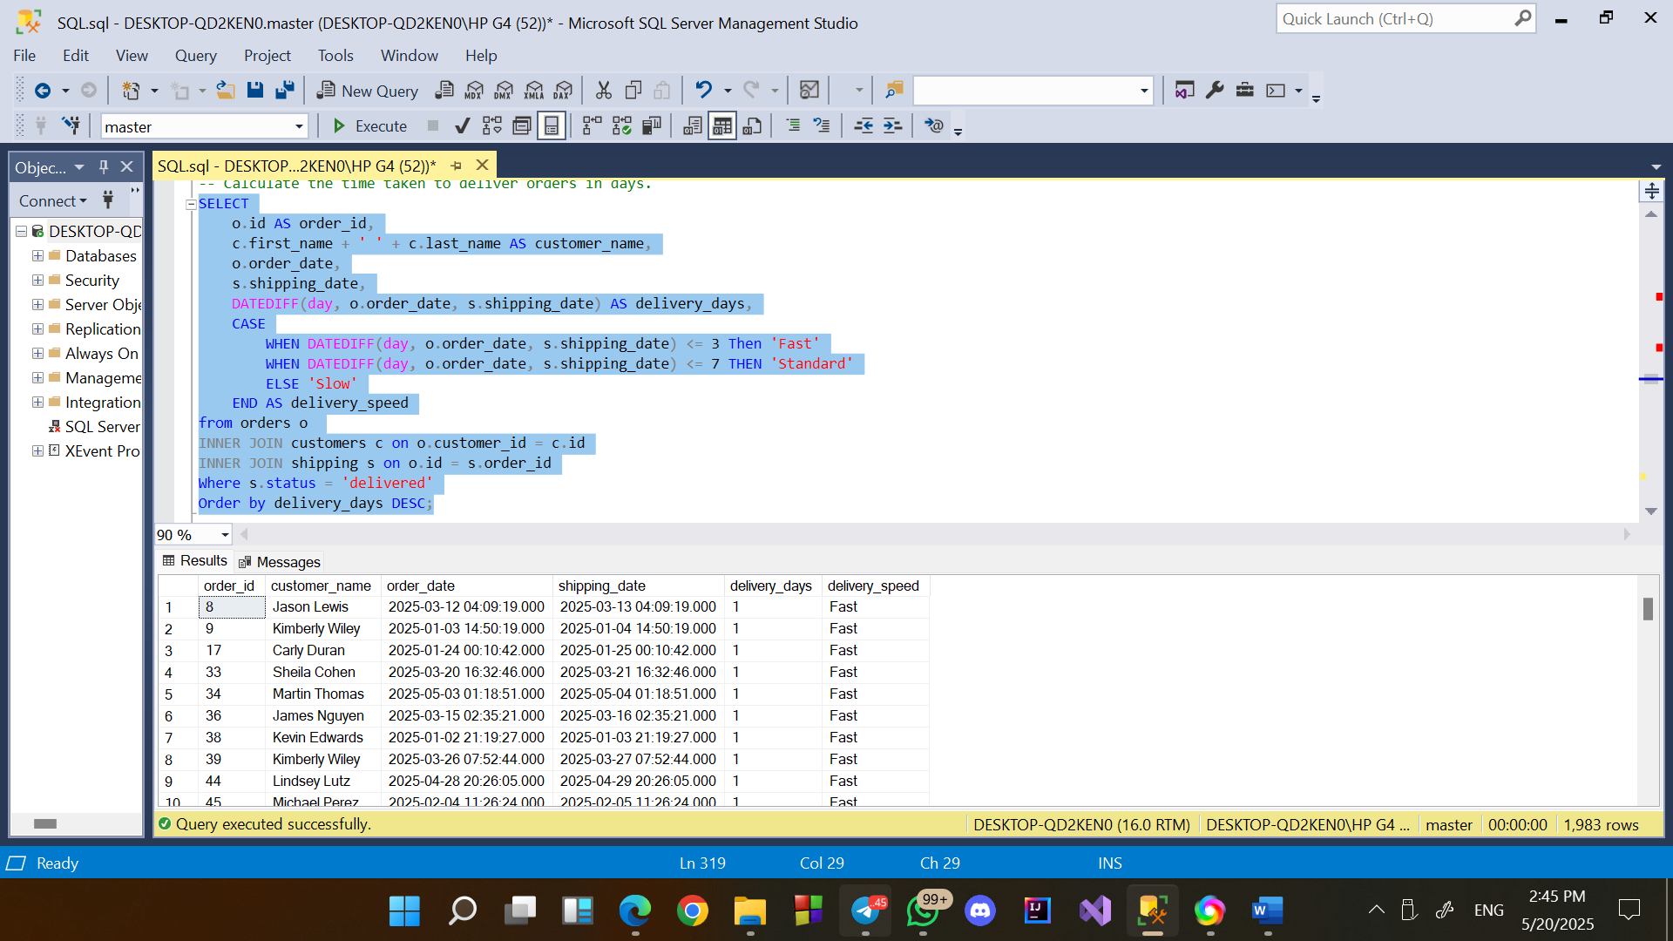

**1. Optimize Shipping Methods**

* Offer customers faster shipping options at checkout (e.g., same-day, express).
* Negotiate better delivery SLAs with logistics providers.

**2. Enhance Order Tracking & Transparency**

* Display estimated delivery time clearly on product and order pages.
* Keep customers informed with real-time tracking updates.

**3. Track Impact of Delivery Time on Customer Satisfaction**

* Correlate delivery delays with refund requests or low ratings.

Prioritize improvements in high-impact areas to enhance customer loyalty

FULL REPORT

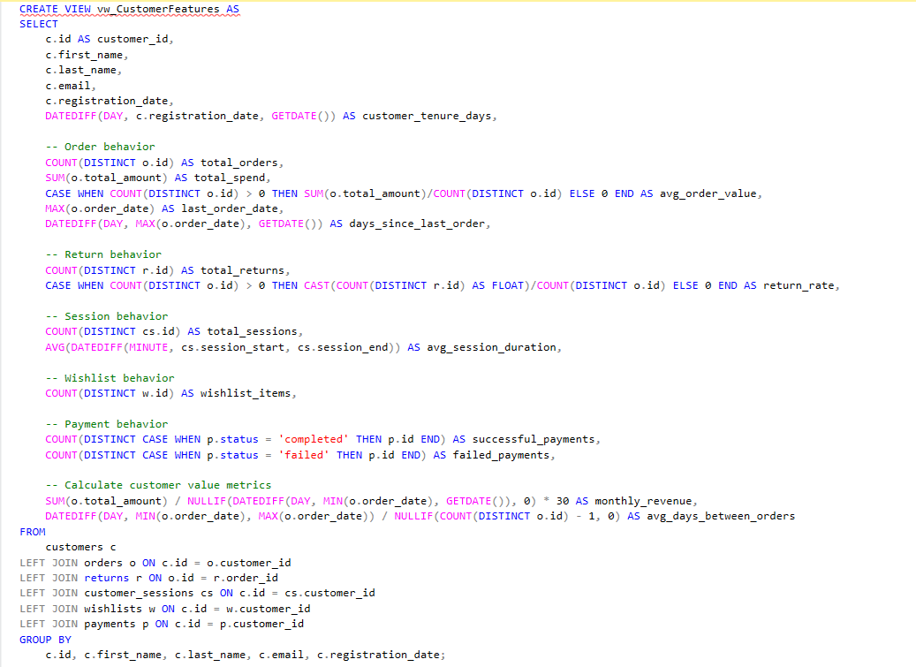

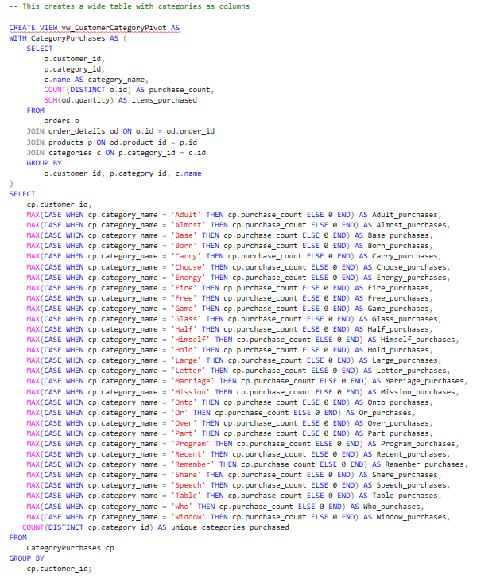

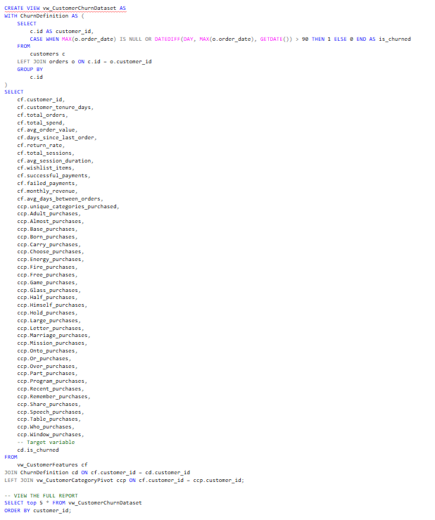

* Calculate the total sales revenue from all orders.

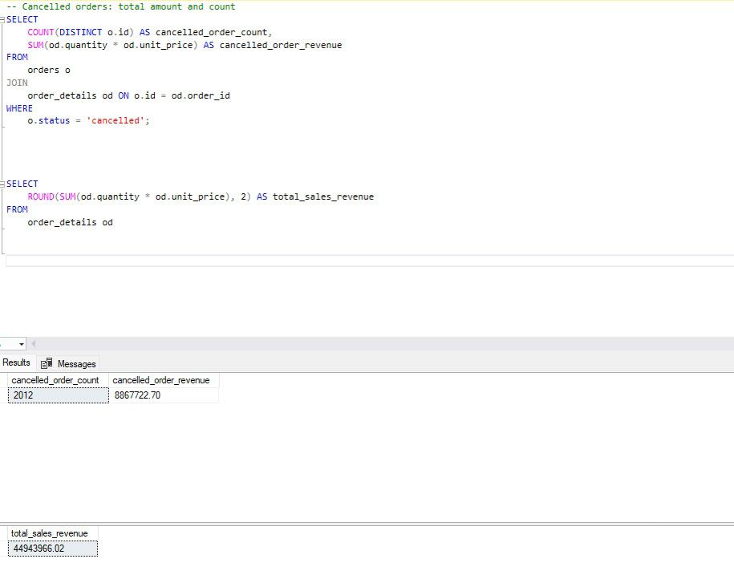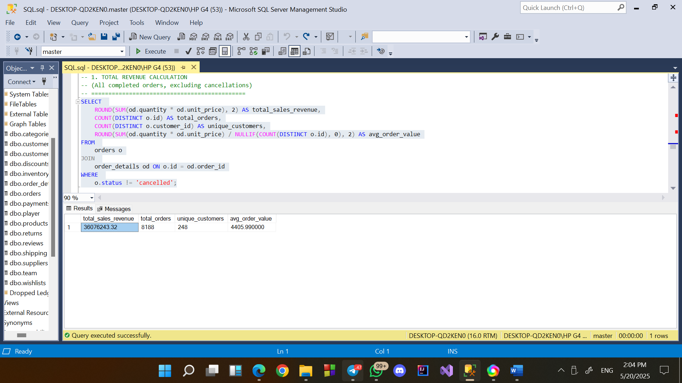

Insights:   
 high revenue per customer, high cancellation rate

Recommendation

expand without losing quality

improving the user experience and providing fast, effective support during the process can

significantly help reduce the cancellation rate.

* List the top 5 best-selling products by quantity sold.

(Ranked by units sold, with revenue)

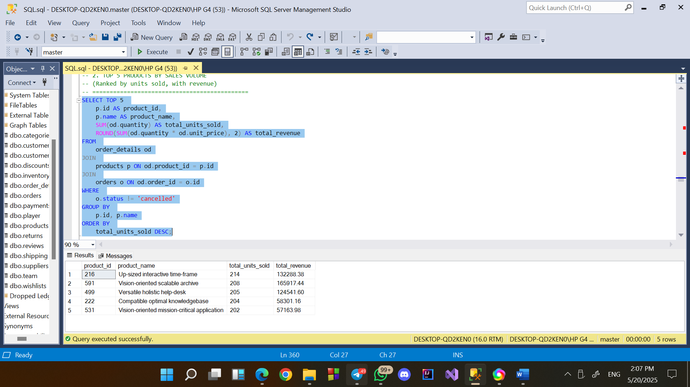

Insights

These products are in consistently high demand, indicating strong customer preference

Recommendation

Due to high turnover, these items should be prioritized in stock planning, reordering, and logistics management to avoid stockouts.

* Generate an alert for products with stock quantities below 20 units.

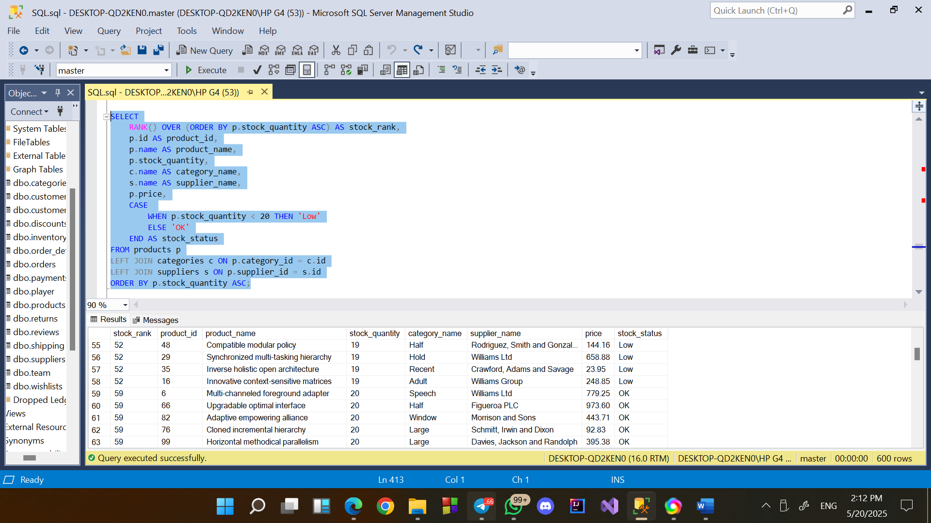

Insights:  
Some products have stock levels below 20 units, indicating a risk of running out of stock.

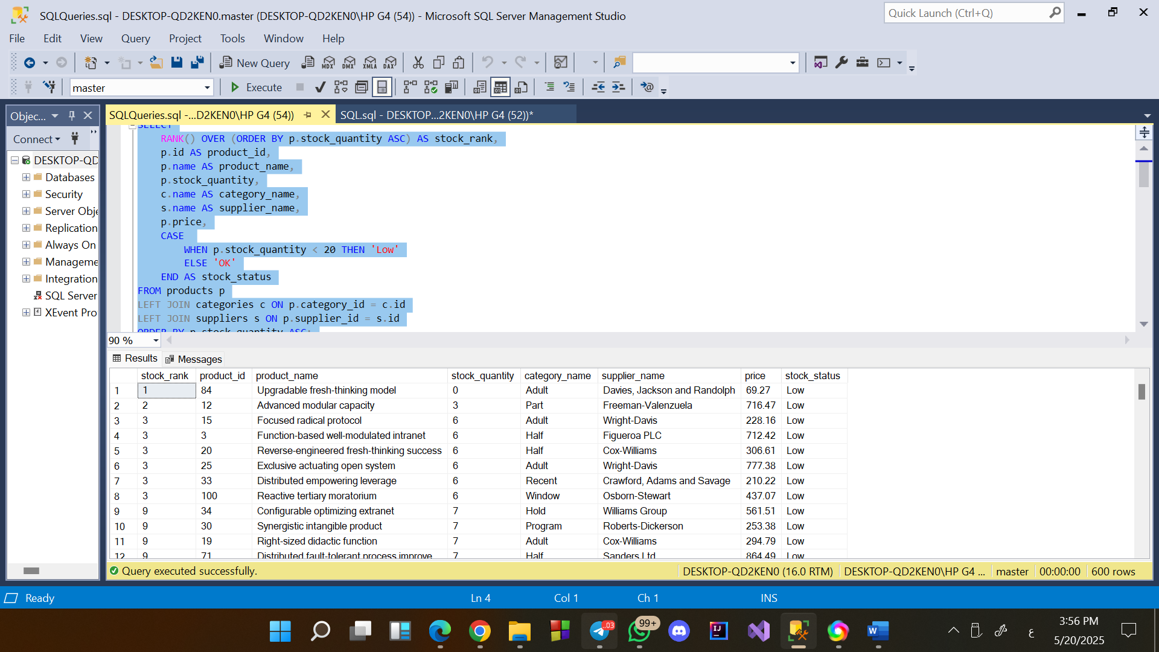

Recommendations:

Restock low inventory items before they run out.

* Determine the percentage of orders that used a discount.

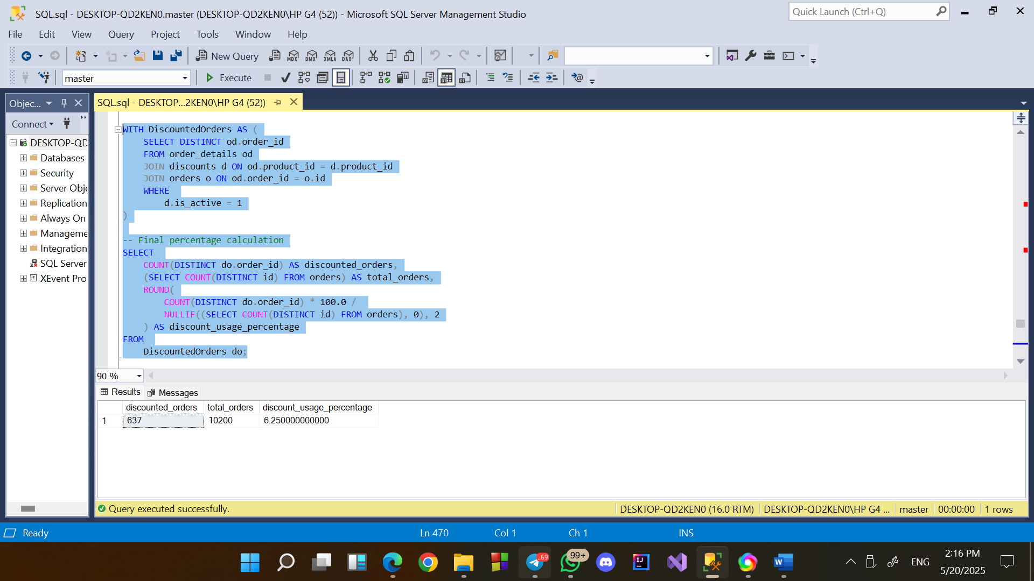

Insights:  
Despite having active discounts, only a small fraction of customers used them during checkout.

Recommendations:

Recheck the rules for applying discounts to make sure they match what customers actually want.

Consider offering more attractive or targeted discounts to increase customer engagement and boost usage rates.

* **Calculate the average rating for each product.**

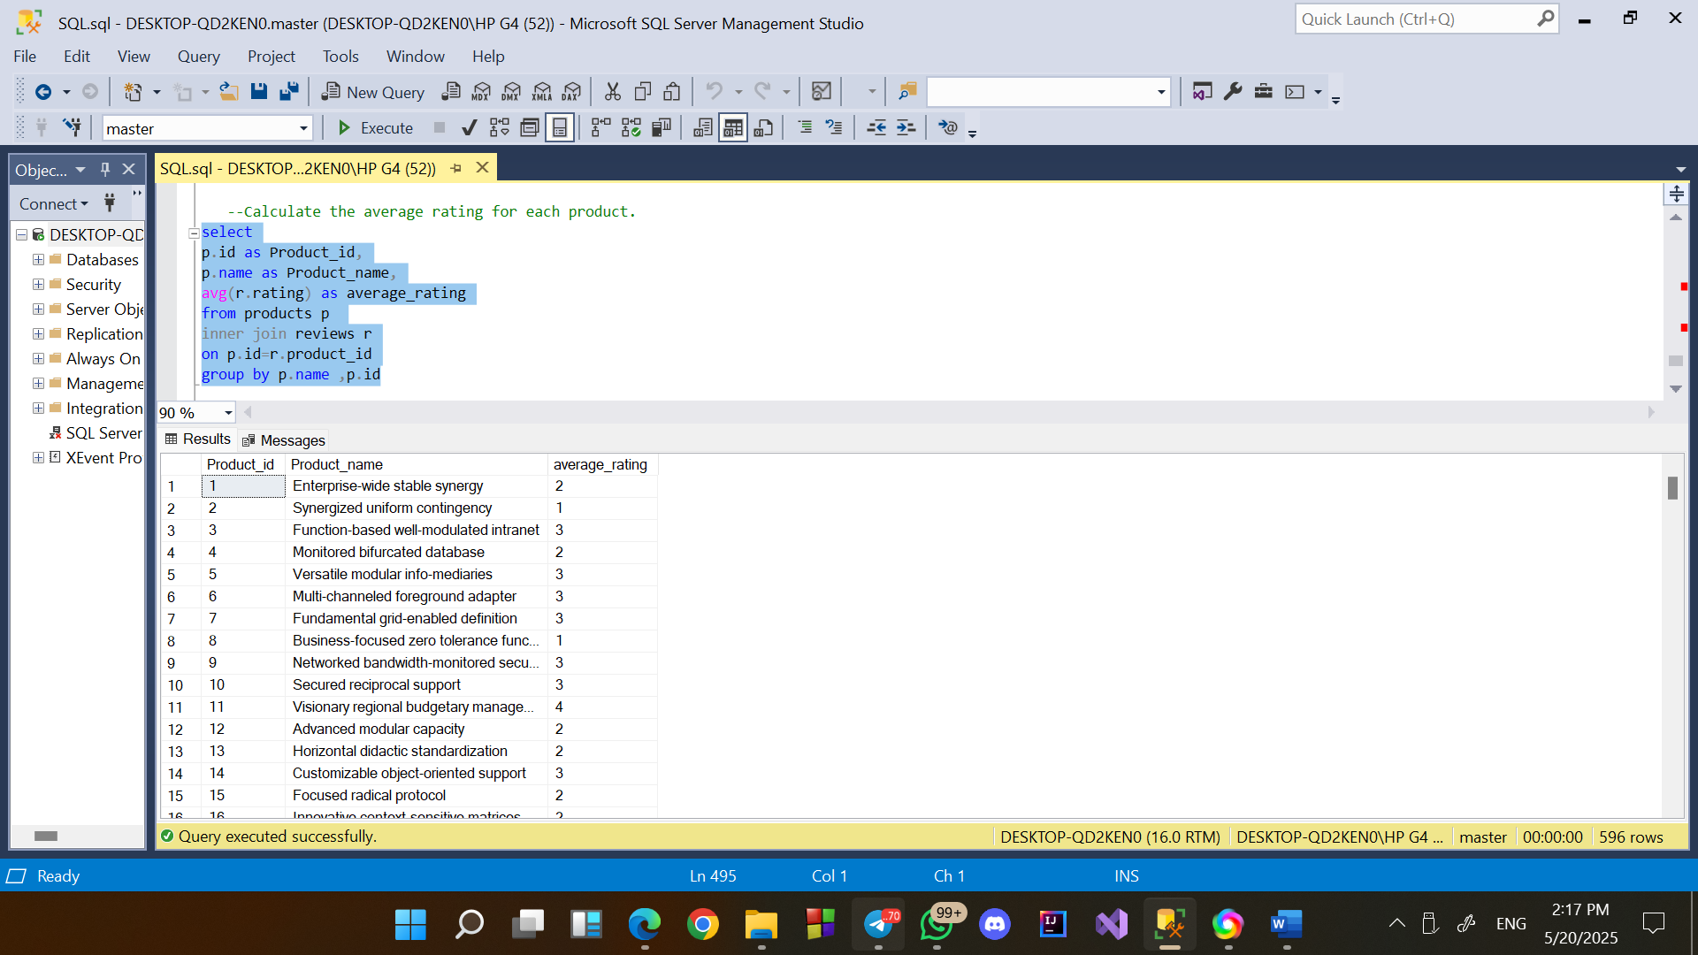

**Insights:**

Several products consistently receive low ratings (3 or below).

**Recommendations:**

* **Focus improvement efforts on products with ratings ≤ 3.**
* **Run surveys for low-rated products to gather detailed feedback.**
* **Send follow-up emails asking happy customers to leave reviews.**
* **Offer small incentives (discounts, loyalty points) for leaving a review.**
* Advanced Queries
* Compute the 30-day customer retention rate after their first purchase.

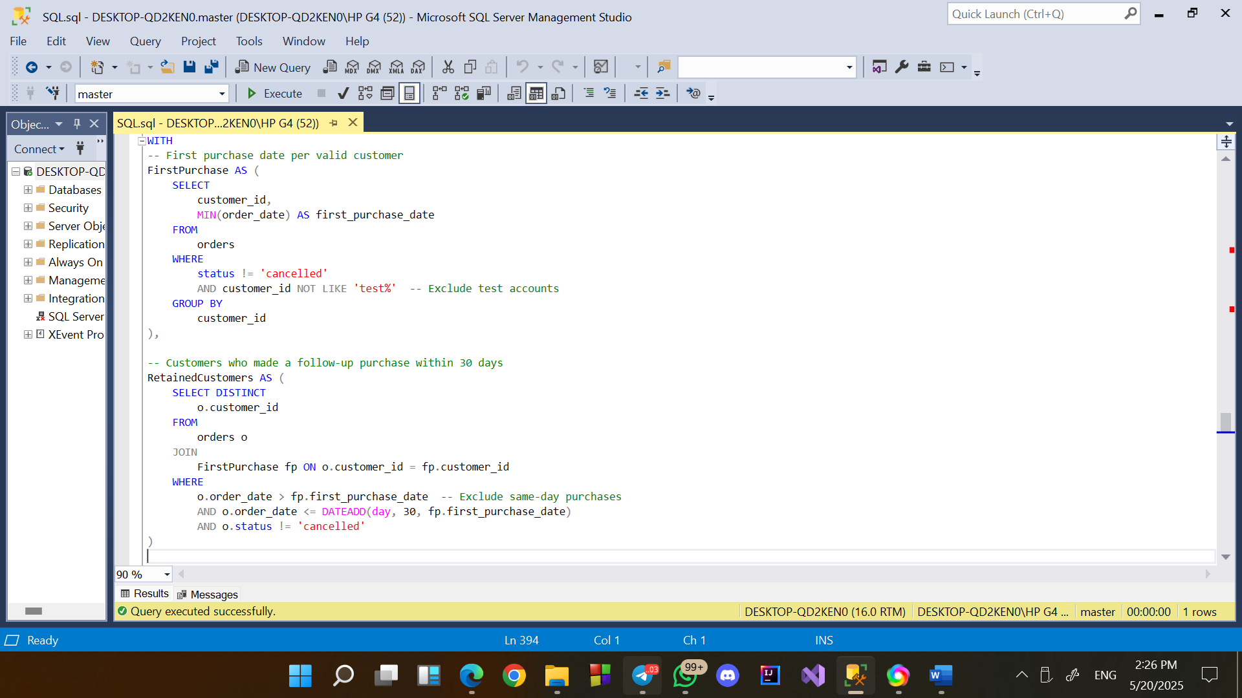

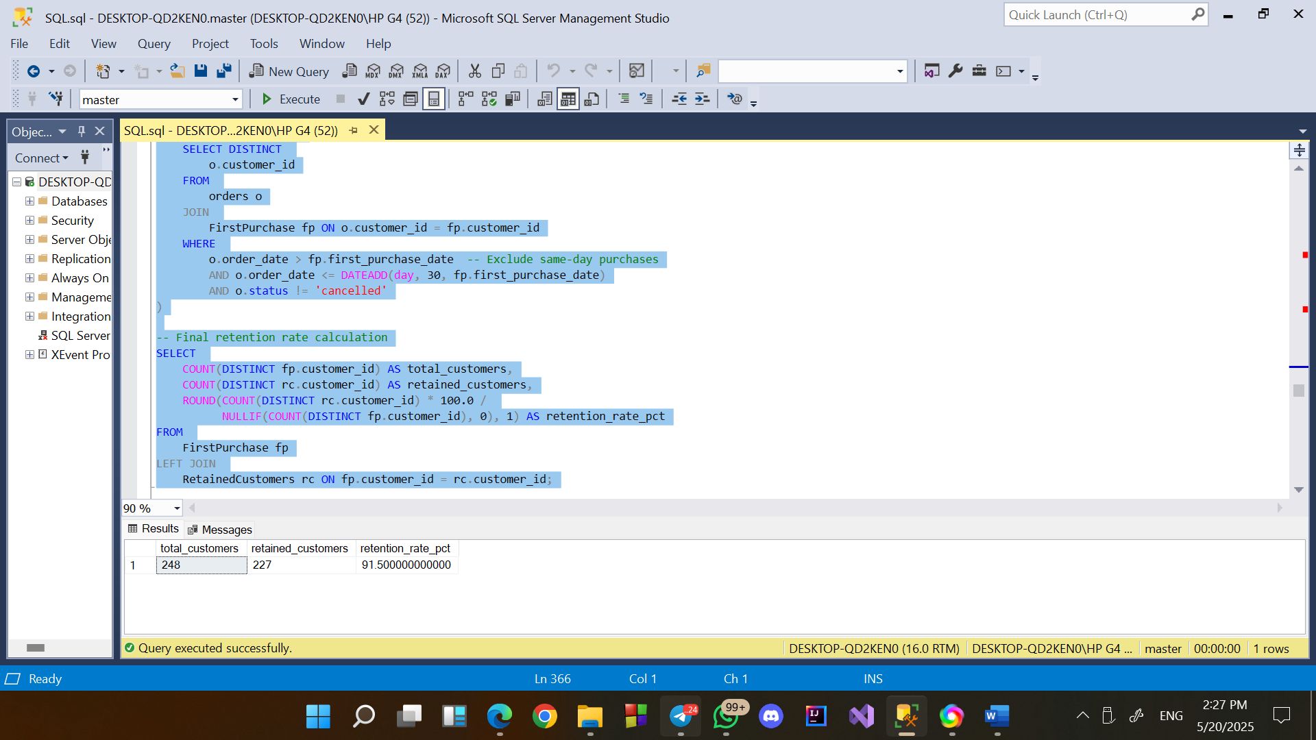

Insights

A 91% 30-day retention rate indicates excellent early customer satisfaction and product-market fit.

High Potential for Long-Term Value

Recommendation

introduce loyalty programs, milestone rewards, or personalized content to keep customers .

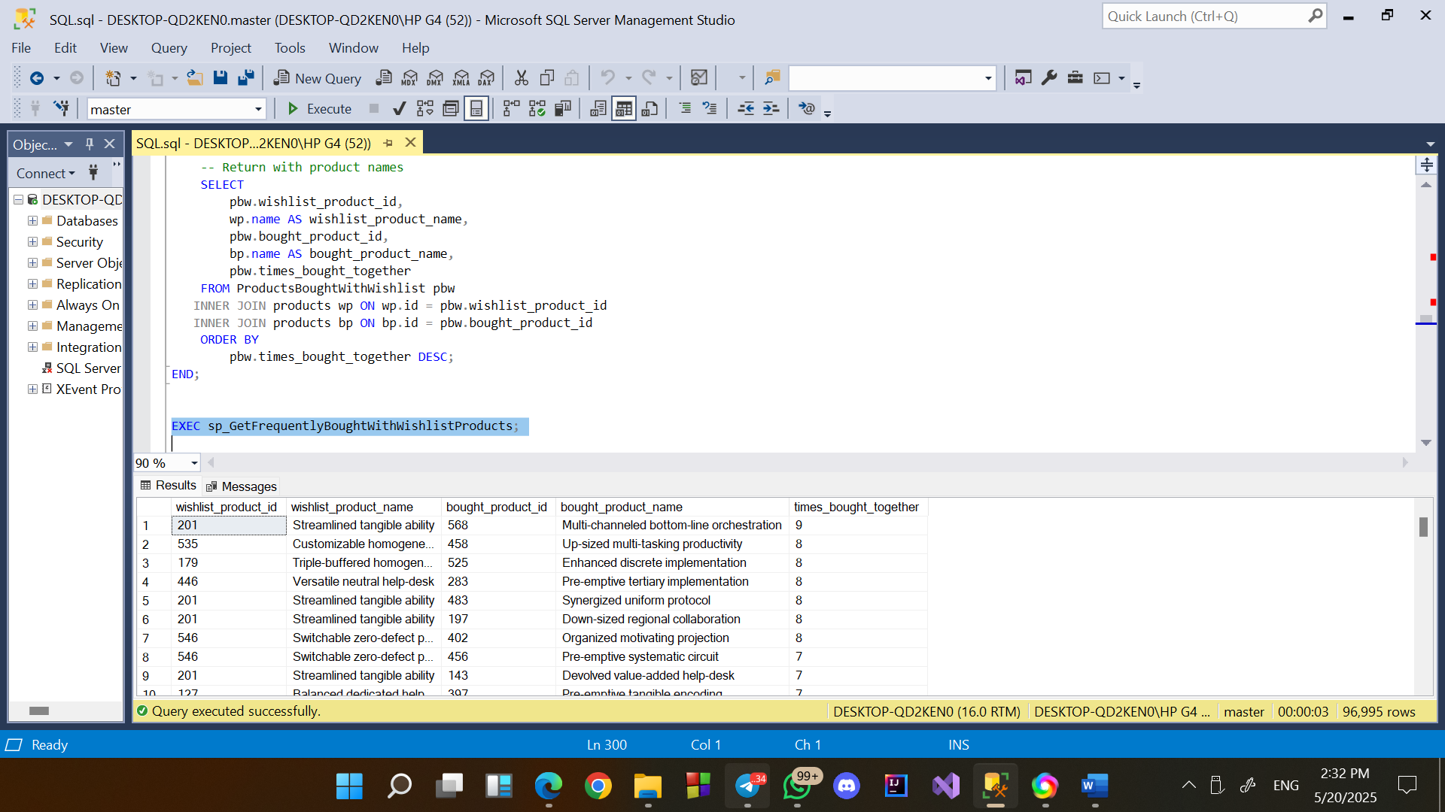

* Track inventory turnover trends using a 30-day moving average.

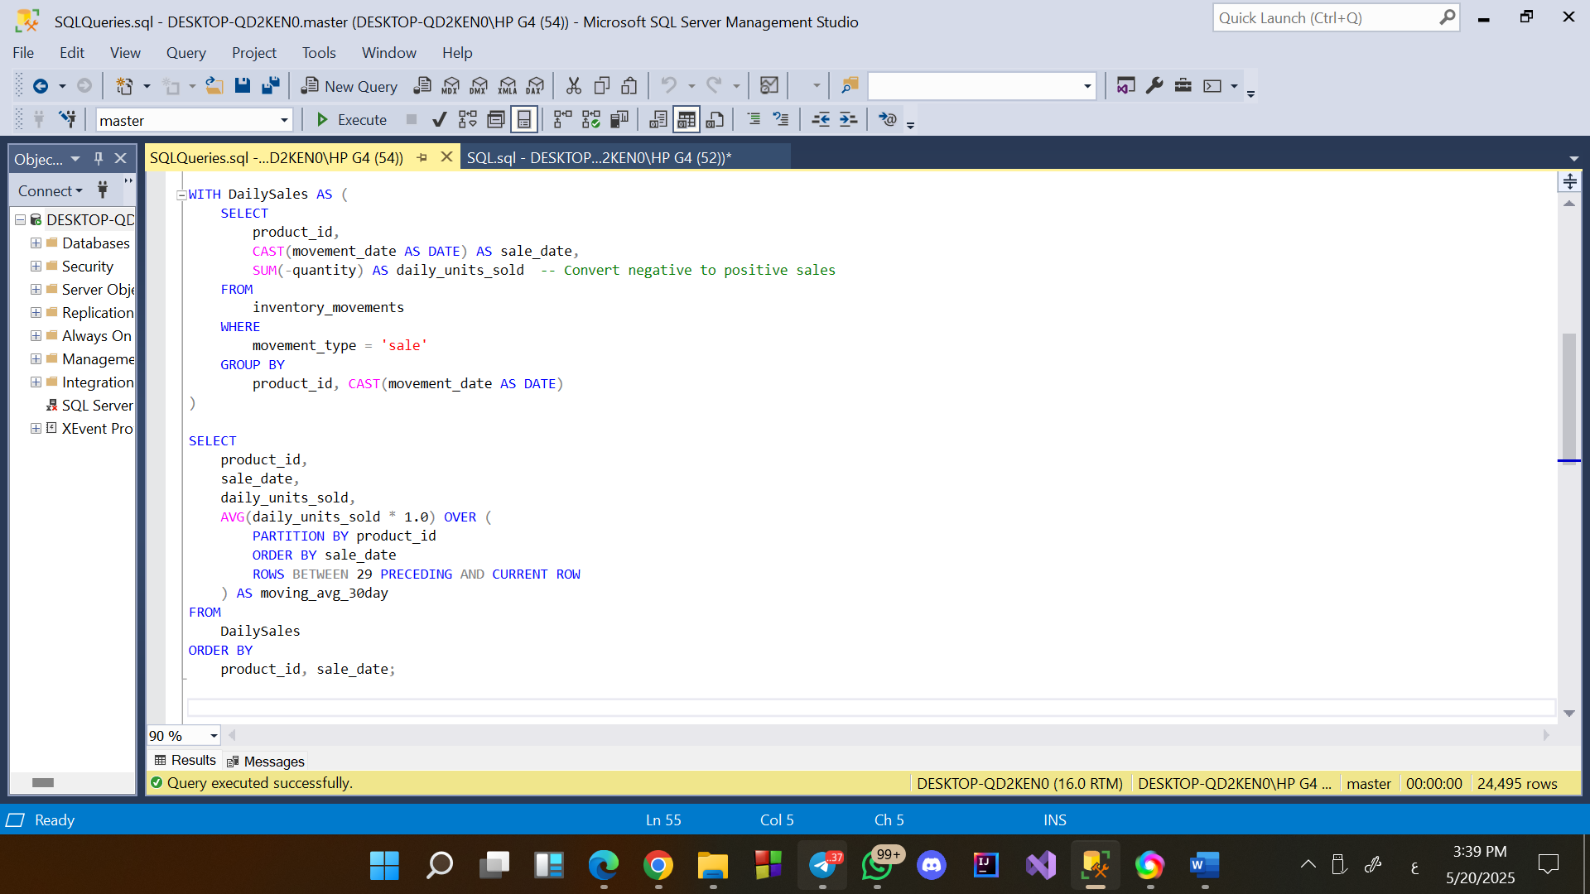

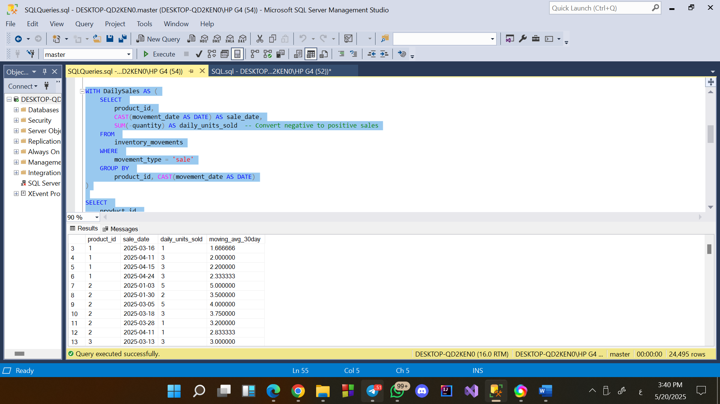

Insights:  
The 30-day moving average reveals trends in product sales over time, helping identify high-demand and slow-moving products.

Recommendations:

Increase inventory for high-turnover products to meet demand, and consider reducing or phasing out slow-moving products to optimize stock levels.

* **Identify customers who have purchased every product in a specific category.**

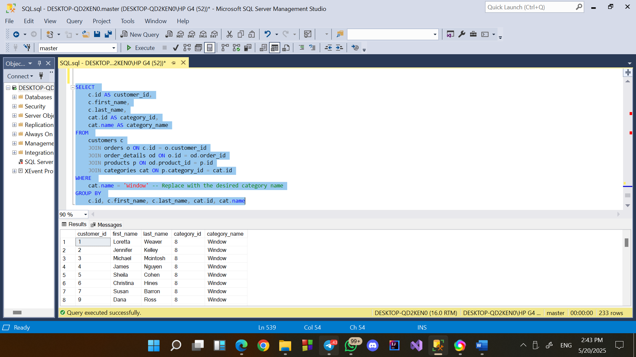

**Insights:**

These customers are **power users** who are not only interested but have completed purchases for the entire product range in this category.

**Recommenditions:**

* Target these customers with complementary product offers.
* Provide a discount or gift for bringing in new customers to purchase from the same category.

**Find pairs of products commonly bought together in the same order.**

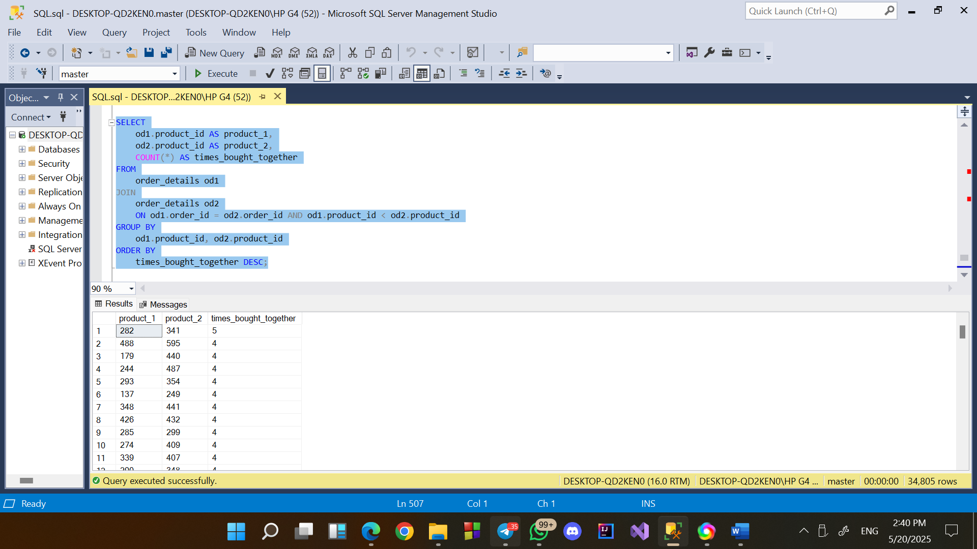

**Insights:**

Products are frequently bought together>1,2.

**Recommenditions:**

-These are good candidates for bundling or combo offers.

- Pairs that are bought together frequently should be stored close together in warehouses to speed up packing.